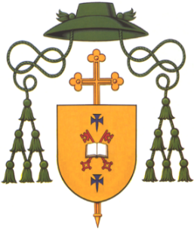**DIOCESE OF DROMORE**

Most Rev Eamon Martin DD

Apostolic Administrator

Bishop’s House

44 Armagh Road

Newry

Co. Down BT35 6PN

**Tel: (028)** **3026 2444**

E-mail: [bishop@dromorediocese.org](mailto:bishop@dromorediocese.org)

**Review of Safeguarding in the Diocese of Dromore**

The Diocese of Dromore has invited the National Board for Safeguarding Children in the Catholic Church in Ireland (NBSCCCI) to conduct a review of safeguarding practice in March 2023.

If you have any views about Safeguarding in the Diocese, we invite you to come forward and email us at safeguarding@dromorediocese.org or contact the Diocesan Office (028 30262444), or to the NBSCCCI (01-5053124).

If you wish to report a child safeguarding concern, please contact Mrs Pat Carville on 07789917741.You may also wish to contact the PSNI (101- non emergency or 999- emergency)

The Gateway Team, (Children’s social services) can be contacted on 028 3741 5285 or Freephone 0800 783 7745

South Eastern Trust, 028 9050 7000

NSPCC 0808 800 5000 [help@nspcc.org](mailto:help@nspcc.org) uk